Ramapo Indian Hills
GRADE 10 Summer Reading 2022

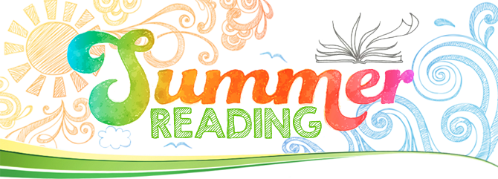

“Today a reader, tomorrow a leader.” -Margaret Fuller

Reading is pleasurable and worthwhile. It offers you the opportunity to travel, to explore new places, and to experience a variety of interesting people and events all from the comfort of your own space. At the same time, reading a good book gives you a chance to practice your comprehension skills, to sharpen your reading rate, and to expand your vocabulary. Reading gives you the best of both worlds!

*All English 2 Honors students are required to read the novel To Kill a Mockingbird by Harper Lee IN ADDITION TO any text of your choice. As this is a core text, please annotate this novel for the elements of narration (characters, setting, plot, conflict, themes, etc.) in addition to completing a one page reaction to it.

Please read the directions below:

- SELECT a book that you have not read before. It may be an intriguing new work of fiction, that dystopian novel your friends are talking about, or even a work of nonfiction about a subject you want to explore. Choose something that interests you! Consider consulting with your current teacher, school or town librarian, parents, and/or peers to help you with the selection process. You may also consult the ‘Book Selection Resources’ at the end of this assignment.

- ENJOY the read! You may wish (though it is not required) to take notes on the elements of narration (characters, setting, plot, conflict, themes, etc.) so that you can recall key points of your reading. You may also make notes or comments about your own personal responses, observations, or questions about what is happening in the book.

- REFLECT on your reading. Once you finish the book, write a 250-350 word typed response. (Honors students--write a response to each book, two responses in total.) Briefly explain why you chose the book and then offer some reaction to it. This might be a personal, creative, or academic response---you decide! The important thing is that your response demonstrates the thinking that you did as a result of the reading. Whatever you do, do not simply summarize the book! (*Once you arrive in class, your teacher will instruct you to submit this work through Turnitin.com, an anti-plagiarism site, so be sure your work is original. )

- SHARE with your teacher and peers. Your thoughtful response to the book and your ability to discuss it in class will be the subject of one of the first assignments of the school year. Your English teacher will provide more details during the first week of school. Just be sure to come to class with your book--or have access to it-- and bring a hard copy of your typed response on
FRIDAY, SEPTEMBER 9, 2022.

HAPPY READING!!!!

BOOK SELECTION RESOURCES

*Parents are urged to assist students in their text selections by consulting reviews at amazon.com and bn.com for additional information. Please be aware that some of the contemporary titles may depict mature and/or controversial topics. Families are encouraged to review titles carefully prior to students’ text selection in order to choose the one that is most suitable.

Suggested Titles:
(*These are merely suggestions! Feel free to choose a book that is not on the list.)

- All the Light We Cannot See by Anthony Doerr
- Science Fair Season: Twelve Kids, a Robot Named Scorch-and What it Takes to Win by Judy Dutton
- Visions of Infinity: The Great Mathematical Problems by Ian Stewart
- The Truth: a Novel of Discworld by Terry Pratchett
- Behind the Beautiful Forever by Katherine Boo
- Feed by M.T. Anderson
- The Future of Us by Jay Asher
- Trail of Broken Wings by Sejal Badani
- The Curious Incident of the Dog in the Night-Time by Mark Haddon
- Invention of Wings by Sue Monk Kidd
- A Long Way Home by Saroo Brierly
- Quiet: The Power of Introverts by Susan Cain
- Extraordinary Means by Robyn Schneider
- I’ll Give You the Sun by Jandy Nelson
- An Abundance of Katherines by John Greene
- Thunderstruck by Erik Larson
- Random Family by Adrian Nicole Leblanc
- Saturday by Ian McEwan
- The Da Vinci Code by Dan Brown
- Room by Emma Donoghue

